**Project Requirement and Specification On**

**Emotion Based Music Player**

*(CSE V Semester Mini Project)*

*2022 – 2023*



Submitted to : Submitted by :

Mr. Ashok Sahoo Jatin Thapliyal

(Mentor) Roll no.:2018395

(CSE-D-V-Sem)

Session : 2022-2023

**GRAPHIC ERA HILL UNIVERSITY DEHRADUN**

**CERTIFICATE**

Certified that **Jatin Thapliyal** (Roll no.- 2018395) has developed mini project on the topic **“Emotion Based Music Player”** for the CSE V Semester in Graphic Era Hill University. The project carried out by student is their own work as the best of my knowledge.

**Mr** **Satvik Vats**

**Class Coordinator**

**B. Tech. Section-D-V-Semester**

**GEHU, Dehradun**

**ACKNOWLEDGEMENT**

I would like to express our gratitude to the Almighty, the most beneficent and the most merciful, for successful completion of the project.

I wish to thank my parent for their continuing support and encouragement. I also wish to thank them for providing me with the opportunity to reach this far in our studies.

I would like to thank my External Supervisor Mr. Satvik Vats for his patience, support and encouragement throughout the completion of this project. At last but not the least, I greatly indebted to others who directly or indirectly helped me during this project.

**Jatin Thapliyal**

**Roll No – 2018395**

**B.Tech.Section-D-V-Sem**

**Session: 2022-2023**

**GEHU DEHRADUN**

**TABLE OF CONTENTS**

**1. INTRODUCTION**

## **2. Requirements of Project**

2.1 Hardware Requirement

2.2 Software Requirement

## **3. Detecting Emotions**

3.1 collecting data

3.2 Machine Learning

3.3 Methods for playing songs

1. **Output**

1. **Conclusion**

1. **References**

CHAPTER – 1

**INTRODUCTION**

People tend to express their emotions, mainly by their facial expressions. Music has always been known to alter the mood of an individual. Capturing and recognizing the emotion being voiced by a person and displaying appropriate songs matching the one's mood and can increasingly calm the mind of a user and overall end up giving a pleasing effect. The project aims to capture the emotion expressed by a person through facial expressions. A music player is designed to capture human emotion through the web camera interface available on computing systems. The software captures the image of the user and then with the help of image segmentation and image processing techniques extracts features from the face of a target human being and tries to detect the emotion that the person is trying to express. The project aims to lighten the mood of the user, by playing songs that match the requirements of the user by capturing the image of the user. Since ancient times the best form of expression analysis known to humankind is facial expression recognition. The best possible way in which people tend to analyze or conclude the emotion or the feeling or the thoughts that another person is trying to express is by facial expression. In some cases, mood alteration may also help in overcoming situations like depression and sadness. With the aid of expression analysis, many health risks can be avoided, and also there can be steps taken that help brings the mood of a user to a better stage.

CHAPTER - 2

**Reqiurements Of Project**

## **Hardware Requirement**

Device Specifications:

o processor : Intel(R)core(TM)i5-8265U CPU @ 1.60GHz 1.80GHz o System :64-bit Operating System ,X64-based processor o Installed Ram : 8.00GB o Windows 10 Home Single Language

## **Software Requirement**

* V.S code o Python (latest version ) installed o Jupyter Notebook o Notepad++

**Libraries :**

* Numpy

**Knowledge :** you should have previous knowledge of : o HTML o CSS o JS o Python

CHAPTER-3

**Detecting emotions**

### Collecting data

Facial expression detection in Fisherface works with the help of trained models. Reason behind this is to allow user to take dataset according to their use. Suppose if we take a huge amount of dataset of around 25-30k it will give nice accuracy no doubt but if the situation is like that the user of the devices are a few people. Now in such condition if we take some precise dataset with around 400-450 images as input releted to the user then it will also give good accuracy with the benefit of less amount of dataset and less storage on memory to operate. As well as small memory of data give output fast which result in quick response time. Here we first tried with Cohn-Kanade dataset then we made some classification in the as our need make it to train our model.

#### Loading and saving trained model

For training, We have used Fisherface method of cv2 library.



For training data model we have make a python code which grab all the classified images from folders and map it with it’s emotion. These data we at an instance stored in dictionary and then use .train method to train model.



To save the model for later use we have implemented .save method.



Now at the detection time first we have load model in memory using .read method.



Prediction of result is based on the prediction and confidence value which .predict method return.



### Haarcascade model

Haarcascade model is precise face detection trained model which is provided by Open-cv. It return the co-ordinates in terms of (x, y) at (left, bottom) of face frame and it’s width and height from those co-ordinates.



As here in the .detectMultiScale() method it is capable of detect multiple faces and it return an array of all the faces(co-ordinates) as an element.

The arguments has set according to the threshold what we need for our checking purpose. We have set it such like it doesn’t affect our model accuracy.

#### Result Calculation

In our model we have not stick on one image for testing, While the code will run it will take around 10 images in a short time(1-2 sec) and for all those images it will compute result and according to the average value of that it will give result. Apart from that we have make two codes one work on single face at a time while another work with multiple faces in the image.

### Machine Learning

Fisherface ML algorithm

Fisherface algorithm is an algorithm which work on the basis of LDA and PCA concepts. Linear discriminant analysis (**LDA**) is a supervised Learning method of machine learning. Now supervised Learning is that where we use such data whose answer is also given to the model to learn it. It work on the concept of dimensionality reduction. Which reduce the execution time among classification. **Principal Component Analysis** (**PCA**) is a one kind of conversion from

correlated variables to uncorrelated in the form of mathematical values. It is mostly used for the observing data and from that by some probabilistic calculation generate models. The flow of Fisherface is like it takes classified images then it will reduce the dimension of the data and by calculating it’s statistical value according the given categories it stores numeric values in .xml file. While prediction it also calculate the same for given image and compare the value with the computed dataset values and give according result with confidence value.

#### Resizing images

Whatever the image we have chosen for dataset it mostly related to the size which can give an precise output. The size is chosen such like the model can able to easily distinguish face from image by haarcascade model. And the size what we get from real time scan is not always same as data (very less difference) so, We resize it to the exact model data size. In our case we have chosen 350*350.

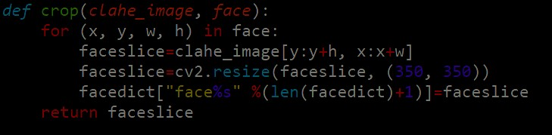

Here In this method, we have implemented the cropping of image by given parameters of haarcascade by clahe_image[] and use of cv2’s method .resize() to the given size. Finally, We have stored those images in dictionary and after some count(=10) take it to check result.

#### **Grey scaling images**

It was the need for the method and because of its contrast and shaded face, it result in benefit for algorithm to get output.

##### Face detection

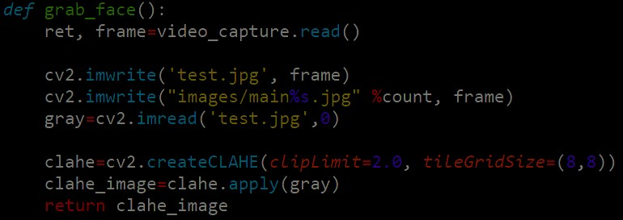

As the given in the code grab_face() methods uses to get the images and do all operation and finally return cropped ,grayed face value in dictionary.

#### **Train and predict methods**



This code is use to get prediction and confidence value for given amount of image. Then get the max function with obtained output and final result is show to the user.

##### **Playing music**

Detected emotions

We have implemented the linking of python with javascript through eel library. Which provide us the privilege to access python methods from js as well as vice versa. Here the striating flow will be in python code as the library is implemented in python then it transfer the control to html, JS. And according to the result we show emoticons.



Sad happy angry neutral

According to which we can classify emotion directory for playing song we have chosen this 4 emotions.

**Methods for playing songs**

In JavaScript file we have implemented too much methods for the switching of song.

1. Queue
2. Based on Emotion
3. Random

In the first one as queue works it has been implemented. In second one we call python code to get emotion from user’s facial expression and according to that chosen next song which is also randomly and played it. In third one we directly used random function and all the methods are dynamic it can handle as change in number of songs according.

CHAPTER – 4

Output

CHAPTER – 5

### **Conclusion**

This is a project using machine learning for detecting emotions based on the expression of the users. This project is made on Python.

A window will open in chrome browser having the interface of the player.

Select emotion mode from the right bottom corner. This will start the webcam. Face will be scanned in the ending of the currently playing song. You can manually move the song controller near the end to start the function.

When emotion is detected, you can see the name of the emotion in the terminal open.

The Emotion Based Music Player is used to automate and give a best music player experience for end user. Application solves all the basic needs of music listeners without troubling them as existing applications do.

It uses technology to increase the interaction of the system with the user in numerous ways.

It eases the work of user by capturing the image using phone’s camera, detecting their emotion and suggesting a customized playlist with advanced features.

CHAPTER -6

**REFRENCES:**

* [**www.google.com**](http://www.google.com/)
* [**https://cfm.ehu.es/ricardo/docs/python/Learning_Python.pdf**](https://cfm.ehu.es/ricardo/docs/python/Learning_Python.pdf)
* **https://wtf.tw/ref/duckett.pdf**
* [**https://github.com/PartheshSoni/emotion-based-music-player**](https://github.com/PartheshSoni/emotion-based-music-player)